Project > Export > JAR File > *Next*

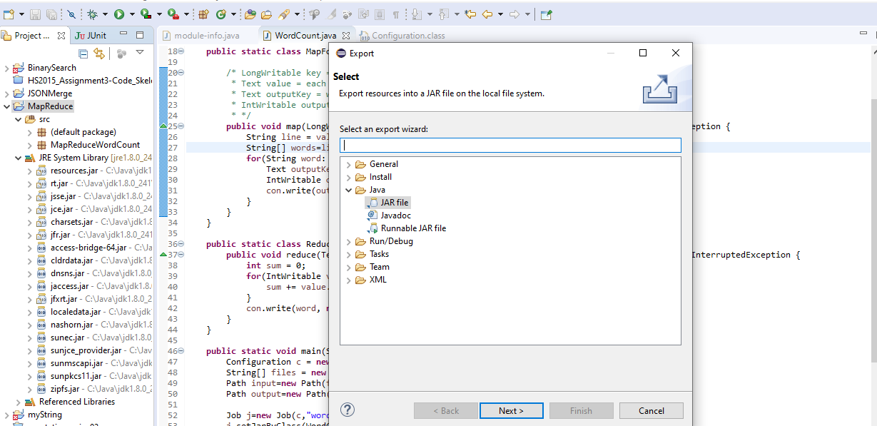

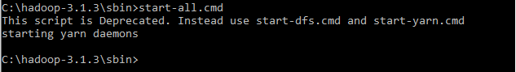

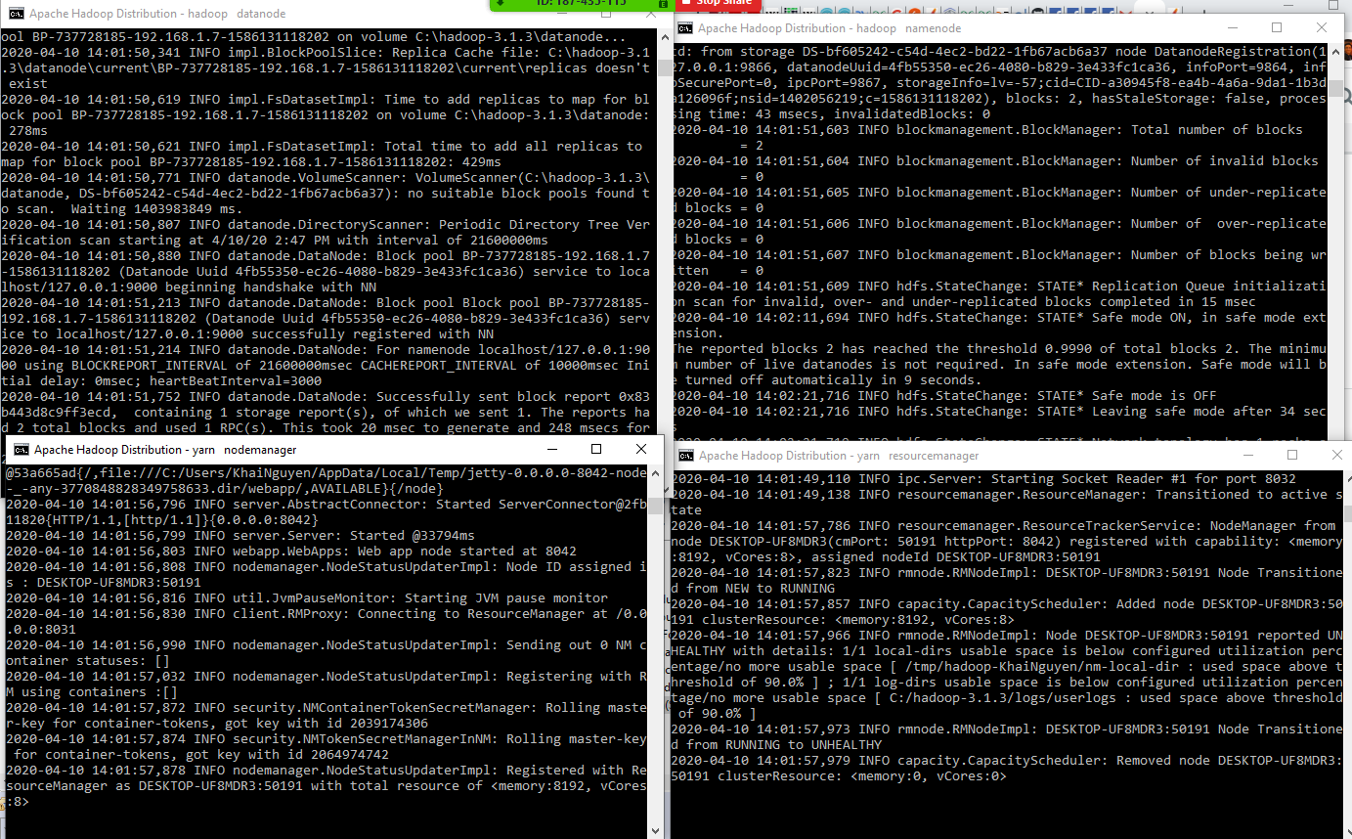

Upload file to HDFS, store in /testKhaiNguyen

C:\Users\KhaiNguyen\Documents\CS_4517\Project\Project_4\MapReduce_Project>hadoop fs -put Pride_and_Prejudice.txt /testKhaiNguyen



C:\Users\KhaiNguyen\Documents\CS_4517\Project\Project_4\MapReduce_Project>hadoop fs -cat /testKhaiNguyen/Pride_and_Prejudice.txt



C:\Users\KhaiNguyen\Documents\CS_4517\Project\Project_4\MapReduce_Project>hadoop jar map_reduce.jar MapReduceWordCount.WordCount /testKhaiNguyen/Pride_and_Prejudice.txt MRDir3

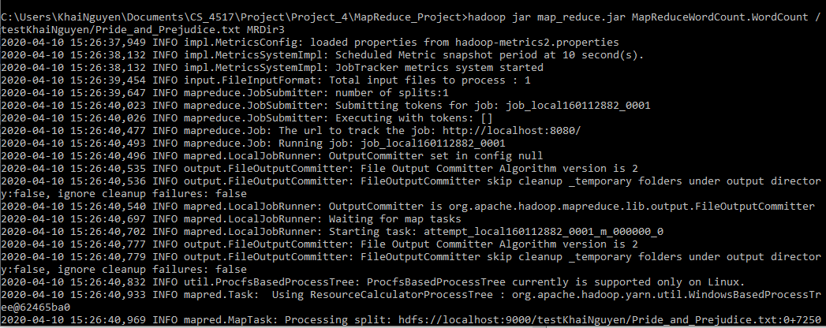

View files created.

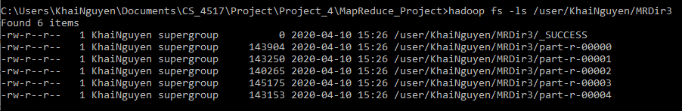

Download files

hadoop fs -get /user/KhaiNguyen/MRDir3/part-r-* .



Sort

hadoop fs -cat /user/KhaiNguyen/MRDir3/part-r-* | sort > ./outputFiles/combined.txt



View number of words OR number of lines since each line is designated for 1 word

find /c /v "" "./outputFiles/combined.txt"





Display last 5 lines. Since there are 6738 lines, we can display the rest of the files starting at line 6733 to get the last 5 lines.

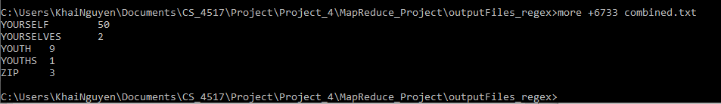

Since there are 6582 lines, we can display the rest of the files starting at line 6577 to get the last 5 lines.

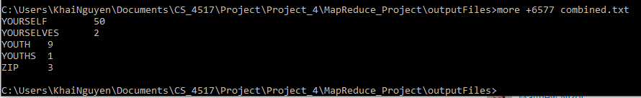

Display first line

more combined.txt

